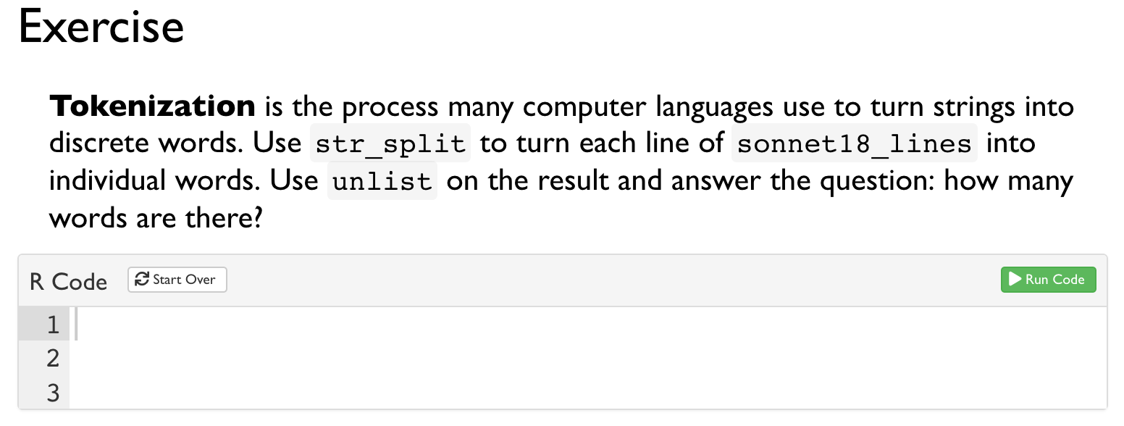

和上一个课件一样, 太长就不全截了



